**Database Design Guide**

This guide will help the student to create a database on the Farmer’s Buddy System. It will help to manage the below functionalities.

* User Details
* Product Details
* Cart
* Order Details
* Payment
* Information about farming related products
* Schemes
* Feedback

We will use MySQL as the DBMS to create the database and its related operations.

**1. Introduction to MySQL**

MySQL is an open-source relational database management system (RDBMS) that uses structured query language (SQL) to manage and manipulate data in a database. It is widely used for various applications, from small web applications to large enterprise systems.

MySQL's key features include:

* Scalability: Capable of handling large amounts of data and concurrent connections.
* Flexibility: Supports various data types and storage engines.
* Performance: Optimized for speed and efficiency.
* Reliability: Known for its stability and robustness.

**2. Installation of MySQL**

MySQL can be installed on various operating systems, including Windows, macOS, and Linux. Here are the general steps to install MySQL:

**Windows:**

* Download the MySQL installer from the official website.

<https://dev.mysql.com/downloads/installer/>

* Run the installer and follow the on-screen instructions.
* Choose the installation type (Typical, Complete, or Custom). Recommended Custom.
* Set a root password for the MySQL server.

**3. E-R Diagram (ERD)**

An Entity-Relationship Diagram (ERD) is a visual representation of the data model that shows the entities, attributes, relationships between entities, and cardinality. ERDs are commonly used in database design to help developers and stakeholders understand the structure and relationships within a database.

**Identify Entities**

* Start by identifying the main entities in your system. These are the objects or concepts about which you want to store data.
* Each entity should correspond to a table in your database.

**Define Attributes**

* For each entity, list the attributes (properties or fields) that describe it.
* These attributes will become columns in the corresponding database table.

**Identify Relationships**

* Determine how entities are related to each other. There are three types of relationships: one-to-one (1:1), one-to-many (1:N), and many-to-many (N:M).
* Represent these relationships using lines connecting the entities.

Let’s see a few examples of relationships:

**One to One**

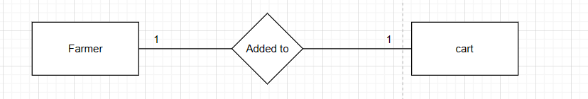

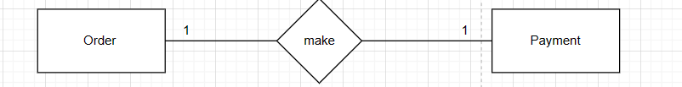

**One to Many**

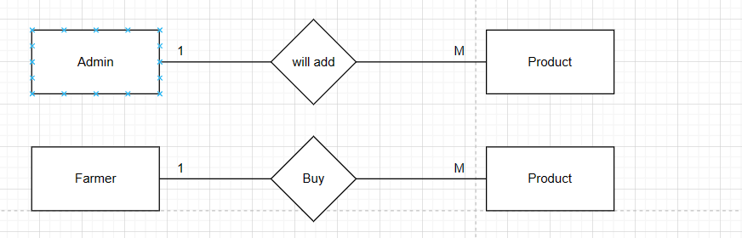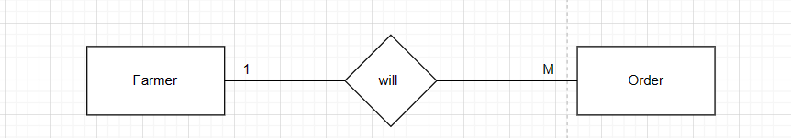

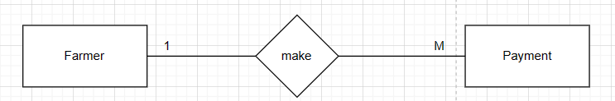

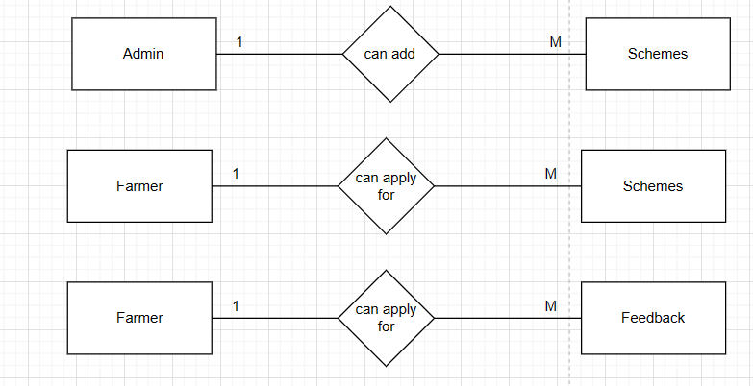

**Many to One**

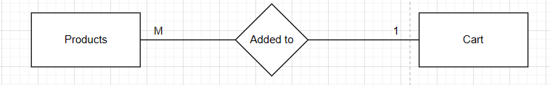

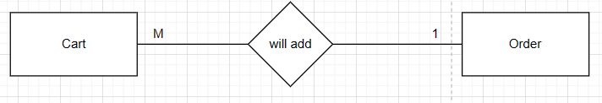

**Many to Many**

**Cardinality Notation**

Cardinality represents the number of times an entity of an entity set participates in a relationship set. Or we can say that the cardinality of a relationship is the number of tuples (rows) in a relationship.

* Use notation (such as Crow's Foot Notation or Chen Notation) to indicate the cardinality of each relationship.
* Cardinality describes how many instances of one entity are related to how many instances of another entity.
* Common notations include:
* One (1)
* Zero or one (0..1)
* Many (N)
* Zero or many (0..N)

**Optional:**

**Add Attributes and Constraints**

* Include additional information in your ERD, such as primary keys, foreign keys, and constraints (e.g., unique constraints).

**Create the Diagram**

* Use specialized diagramming software or tools (e.g., Lucidchart, draw.io, or even pen and paper) to create your ERD.

**Refine and Review:**

* Review your ERD with stakeholders and team members to ensure it accurately represents the data model and relationships. Make any necessary refinements.

Let’s identify the entities of the Student management system

1. Student
2. Course
3. Instructor
4. Enrollment
5. Score
6. Feedback

*** Now let’s identify the attributes and relationships of each entity for the Student Management System.

**Admin**

* **Attributes:**

Admin_id

Password

* **Relationships:**

One **Admin** can add many products and schemes.(One-to-Many)

**Farmers**

* **Attributes:**

Farmer_ID (Primary Key)

Farmer_Name

Password

Email

Phone_No

* **Relationships:**

One **Farmer** can Register them self Only Ones. (**One-to-One**)

**Products**

* **Attributes:**

P_Id (Primary Key)

P_Name

Descpt

Price

* **Relationships:**

One **Farmer** can buy many **Products** (**One-to-Many**)

**Cart**

* **Attributes:**

Farmer_Id (Foreign key)

P_Id (Foreign Key)

P_Name

Price

Quantity

* **Relationships:**

One **Farmer** can have **Cart** (**One-to-Many**)

**Orders**

* **Attributes**:

Order_ID (Primary Key)

Farmer_ID (Foreign key)

Name

Address

Amount

* **Relationships:**

One **Farmer** can **Order many Products  (One-to-Many)**

**Payment**

* **Attributes**:

Payment_ID (Primary Key)

Farmer_ID (Foreign key)

Order_ID (Foreign key)

Payment_Type

Cvv

Amount

Cardholder_Name

Expiry_Date

* **Relationships:**

One **Farmer** can do Payment many times.**(One-to-Many)**

**Schemes**

* **Attributes**:

Schemes_ID (Primary Key)

Accountholder_Name

Name

Bank_Name

Account_No

Farmer_ID (Foreign key)

* **Relationships:**

One **Farmer** can apply for many Schemes.**(One-to-Many)**

**Feedback**

* **Attributes**:

Feedback_No (Primary Key)

Farmer_ID (Foreign key)

Phone_No

Quality

Suggestion

* **Relationships**:

  One **Farmer** will maps to Many **Feedbacks** (**One-to-Many**)

**Table Structure**

1. **Admin**

create table Admin(

Admin_Id int(10) primary key,

Pass varchar(20) NOT NULL

);

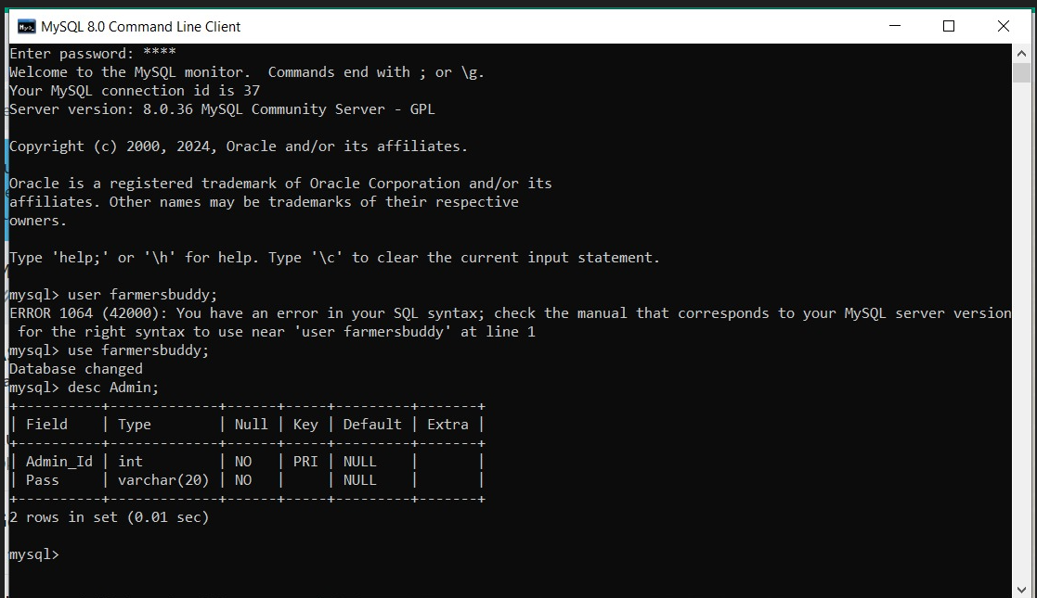

1. **Farmer**

create table Farmer(

Farmer_Id int(10) primary key,

Farmer_Name varchar(50) NOT NULL,

Pass varchar(20) NOT NULL,

Email varchar(50) NOT NULL unique,

Phone_no int (10) NOT NULL

);

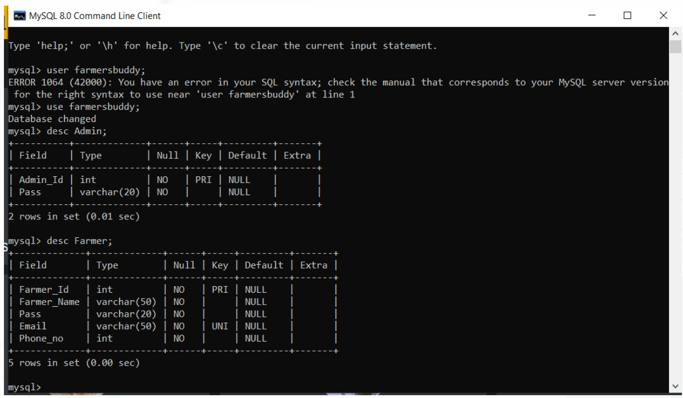

1. **Product**

create table Product(

P_Id int(10) primary key,

P_Name varchar(50) NOT NULL,

Descpt varchar(200) NOT NULL,

Photo varchar(50) NOT NULL ,

Price int NOT NULL

);

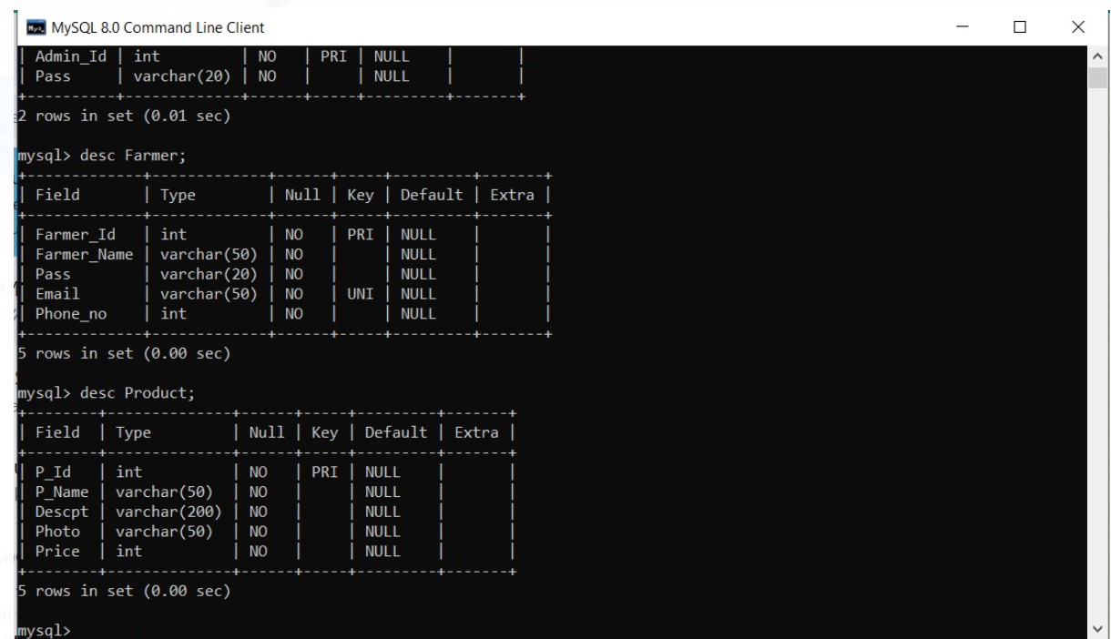

1. **Cart**

create table Cart(

Farmer_Id int(10) NOT NULL,

P_Id int(10) NOT NULL,

P_Name varchar(50) NOT NULL,

Descpt varchar(200) NOT NULL,

Price int NOT NULL,

Quantity int NOT NULL,

constraint FK_ProductID foreign key (P_Id)

references Product(P_Id),

constraint FK_CustomerID foreign key (Farmer_Id)

references Farmer(Farmer_Id)

);

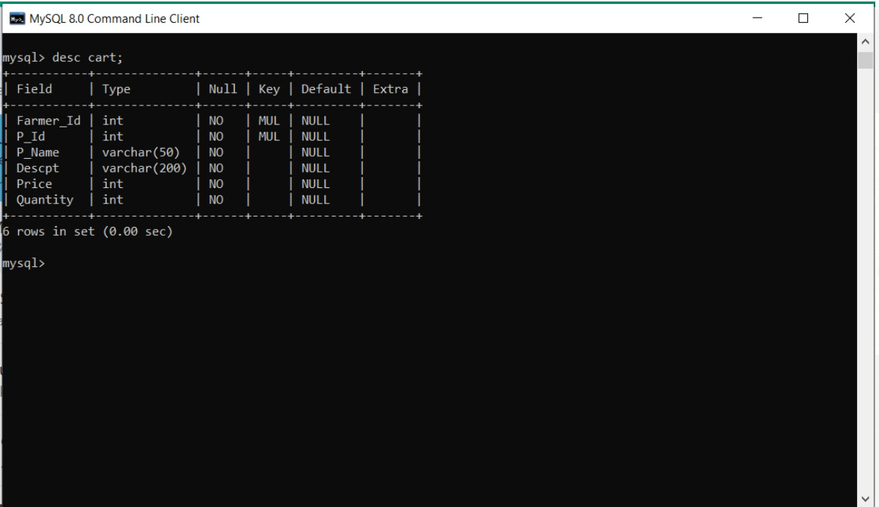

1. **Order**

create table Orders(

Order_Id int(10) primary key,

Phone_no int(10) NOT NULL,

Name varchar(50) NOT NULL,

Address varchar(200) NOT NULL,

Amount int NOT NULL,

Farmer_Id INT NOT NULL,

constraint FK_UserID foreign key (Farmer_Id)

references Farmer(Farmer_Id)

);

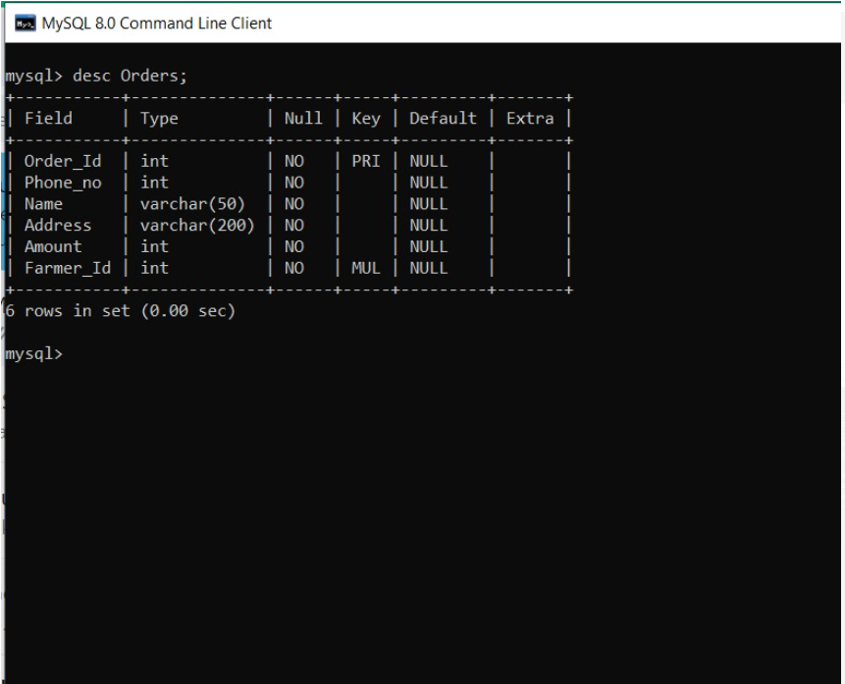

1. **Payment**

create table Payment(

Farmer_Id int(10) NOT NULL,

Cardholder_Name varchar(50) NOT NULL,

Amount int NOT NULL,

Cvv int(3) NOT NULL,

Expiry_Date varchar(20) NOT NULL,

Order_Id int(10) NOT NULL,

Payment_Id int(20) NOT NULL,

Payment_Type varchar(20) NOT NULL,

constraint FK_OrderID foreign key (Order_Id)

references Orders(Order_Id),

constraint FK_UsersID foreign key (Farmer_Id)

references Farmer(Farmer_Id)

);

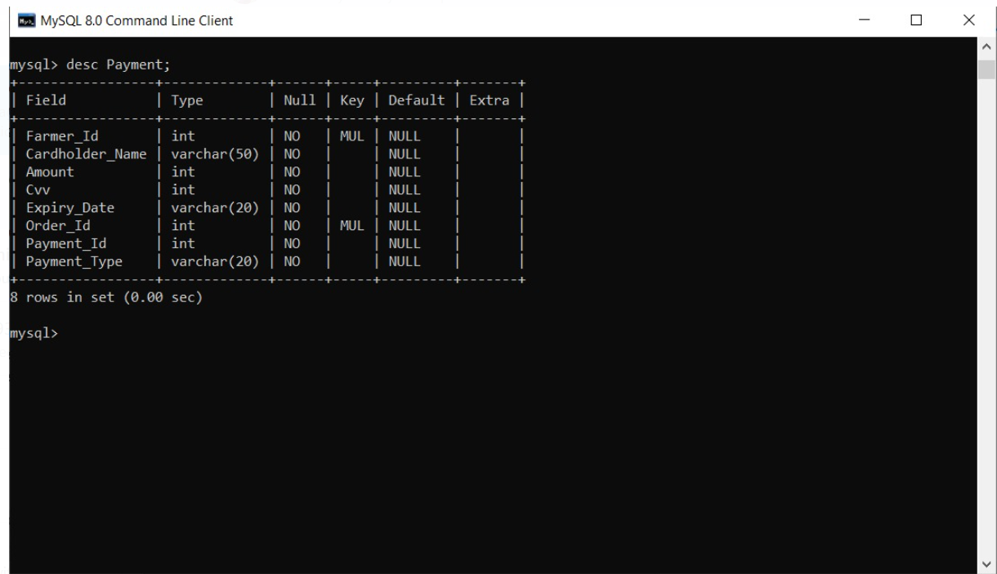

**7.Schemes**

create table Schemes(

Farmer_Id int(10) NOT NULL,

Accountholder_Name varchar(50) NOT NULL,

Name varchar(50) NOT NULL,

Account_No int(14) NOT NULL,

Bank_Name varchar(50) NOT NULL,

constraint FK_SchemesID foreign key (Farmer_Id)

references Farmer(Farmer_Id)

);

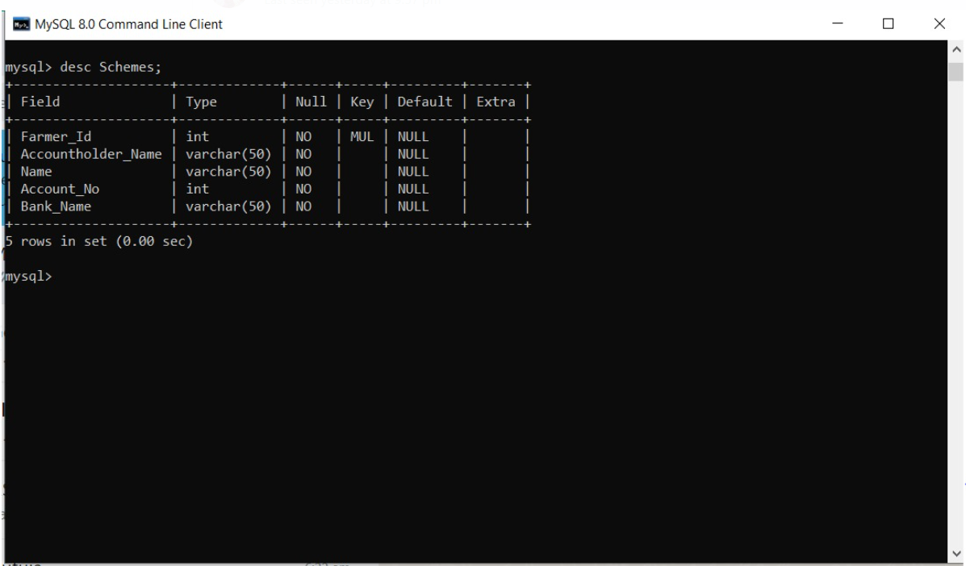

**8.Feedback**

create table Feedback(

Feedback_No int(10) primary key,

Farmer_Id int(10) NOT NULL,

Phone_no int(10) NOT NULL,

Quality varchar(50) NOT NULL,

Suggestion varchar(50) NOT NULL,

constraint FK_FeedbackID foreign key (Farmer_Id)

references Farmer(Farmer_Id)

);

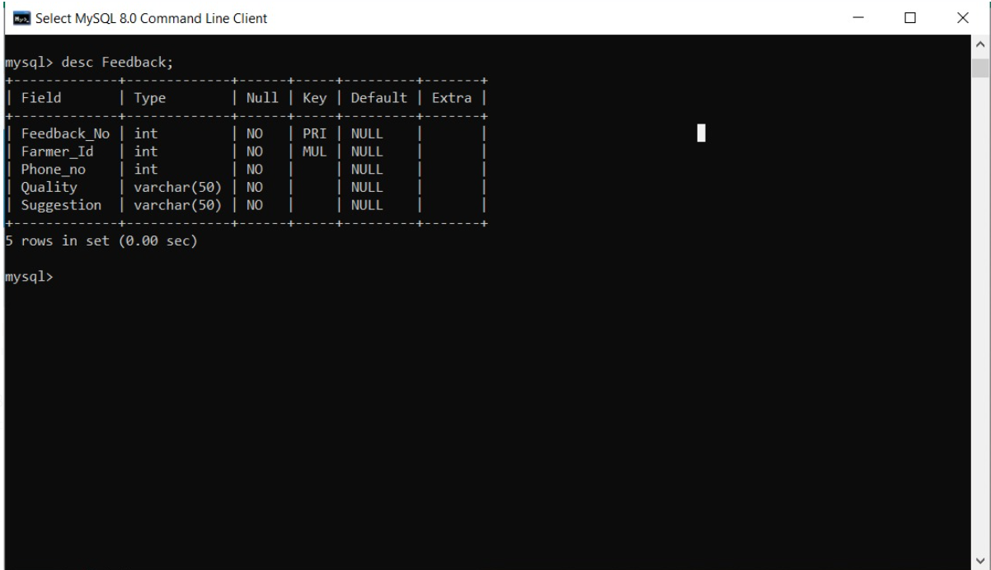

Now, let’s create the ER diagram to visually represent the entities and relationships.

**ERD Diagram**

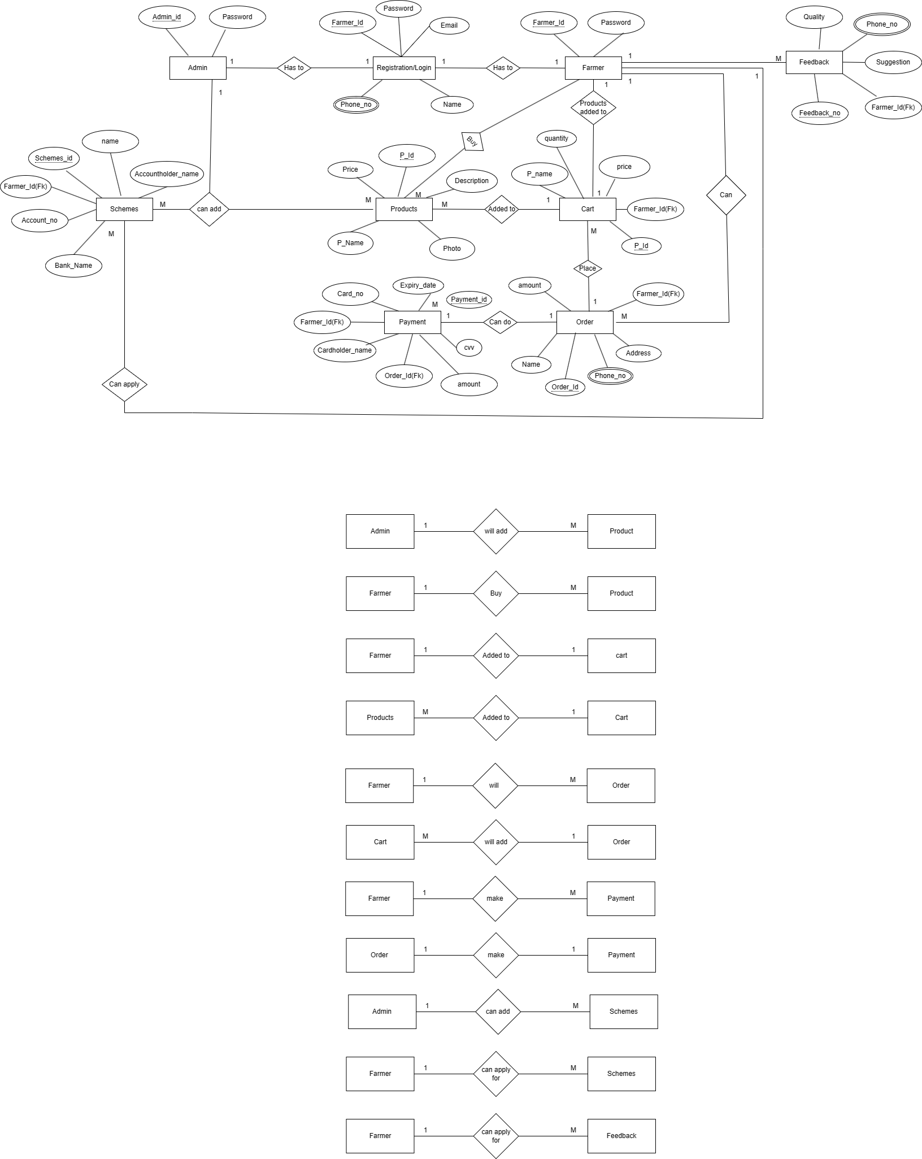

**In this ERD:**

* Students can enroll, and each course can have multiple students, creating a many-to-many relationship.
* The Enrollment entity serves as a bridge table between Student and Course entities to represent this relationship.
* Multiple courses can be taught by one Instructor (many-to-one relationship).
* Each Instructor can teach multiple courses (one-to-many relationship).
* A student can give multiple feedbacks
* Student may have scores of multiple courses

**4. Creating a Database**

Using MySQL server, create a new database for your student management system. You can do this with SQL commands or through the graphical interface.

*CREATE DATABASE StudentManagementSystem;*

**5. Using a Database**

Before performing any operations on a database, you need to select it using the USE statement:

*USE StudentManagementSystem;*

**6. Creating the tables for each entity**

**PN:** Ideally no data should be deleted from any tables. You can use an additional column to set the status of that record to ‘Active/Inactive’, etc. Or you can use an Archive table to move the unnecessary records out of the main table.